Methods

Based on the algorithm above, the MATLAB® code is mainly comprised of four portions:

1. Source data preparation. First a head phantom image is made using function *Phantom= phantom (def,n)*, then the CT scan process is simulated by the built-in Radon transform function *Radon=radon(Phantom,theta)*. The result (Figure 1) is our source data for image reconstruction.
2. Since each column of Radon matrix is the projection at certain angle θ, we apply 1D Fourier transform to each column, i.e. fft across the dimension 1, shift the zero-frequency component to the center and get 2D Fourier space arranged in radial grid, using the user-defined function *Fourier_radial=ft1D(Radon_pad)* (Figure 2). Each column of matrix *Fourier_radial* is a central slice in 2D Fourier space at certain angle θ. Prior to 1D FT, the *Radon* matrix is zeropadded by function *zeropad* to make the length of the column next power of 2 to improve FFT efficiency. For instance, if the original length of the column is 287, it would be elongated length of 512 by adding zeros to both sides of the column array.
3. A rectangular grid of the same size as original image matrix is defined in 2D Fourier space, and then converted to polar coordinates using function *cart2pol*. The value in the matrix *Fourier_2D* (Figure 3) is obtained by interpolating the matrix *Fourier_radial*, using function *interp2*.
4. The zero-frequency component of the 2D Fourier matrix, *Fourier_2D*, is first shifted to upper left corner by function *ifftshift*, then undergoes 2D inverse Fourier transform, and finally shifted back by function *fftshift*. Generally the result may contain complex value, so absolute value of the matrix is taken to be the reconstructed image matrix and plotted.

|  |  |
| --- | --- |
| Figure 1 Radon transform | Figure 2 1D Fourier transform |
| Figure 3 Interpolated 2D Fourier space |  |

Analysis

In order to evaluate and compare the performance of our reconstruction method and MATLAB® *iradon* function, the function *evaluation* defines Mean Squared Error (MSE), a measurement standard for difference between the reconstructed and original image, which sums up the difference of two image matrix and is then divided by number of pixels. Also the time cost of the reconstruction methods is recorded using command *tic toc*.

Number of Projections Used

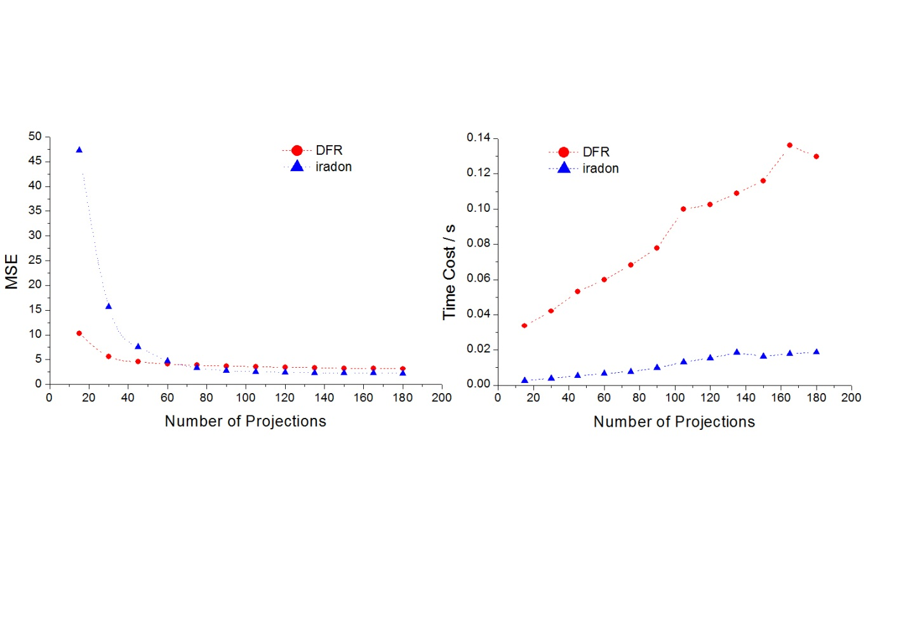

|  |  |  |
| --- | --- | --- |
|  |  |  |
|  |  |  |

Image Size

Different Interpolation Schemes

Noise Tolerance

Resolution Limits

% BMEN E4984 Biomedical Imaging Project

% CT image reconstruction using Direct Fourier Reconstruction

% Siheng He, Natalie Delpratt

%%%%%%%%%%%%%%%%%%%%%%%%%%%%%%%%%%%%%%%%%%%%%%%%%%%%%%%%%%%%%%%%%%%%%

% Evaluate the effct of number of projections

num_proj = [45 90 180 360];

SSE_proj = zeros(length(num_proj),2);

time_proj = zeros(length(num_proj),2);

N_image=201;

for i=1:length(num_proj)

N_theta = num_proj(i);

tic

Reconstruct_image = FourierReconstruction(N_theta,N_image,'linear',inf,0);

time_proj(i,1) = toc;

save_result(Reconstruct_image,strcat('Number of Projections: ',...

num2str(N_theta)));

SSE_proj(i,1) = evaluation(N_image,Reconstruct_image);

d_theta = 180/N_theta;

theta = linspace(0,180-d_theta,N_theta);

rad = radon(phantom(N_image),theta);

tic

irad = iradon(rad,theta);

time_proj(i,2) = toc;

save_result(irad,strcat('Number of Projections: ',num2str(N_theta),...

'(iradon)'));

SSE_proj(i,2) = evaluation(N_image,irad(1:N_image,1:N_image));

end

%%%%%%%%%%%%%%%%%%%%%%%%%%%%%%%%%%%%%%%%%%%%%%%%%%%%%%%%%%%%%%%%%%%%%

% Evaluate the effct of image size

N_theta = 180;

image_size = [201 301 401 501];

SSE_size = zeros(length(image_size),2);

time_size = zeros(length(image_size),2);

d_theta = 180/N_theta;

theta = linspace(0,180-d_theta,N_theta);

for i=1:length(image_size)

% evaluate DFR

N_image = image_size(i);

tic

Reconstruct_image = FourierReconstruction(N_theta,N_image,'linear',inf,0);

time_size(i,1) = toc;

save_result(Reconstruct_image,strcat('Image Size: ',...

num2str(N_image)));

SSE_size(i,1) = evaluation(N_image,Reconstruct_image)/(N_image/201)^2;

% evaluate iradon

rad = radon(phantom(N_image),theta);

tic

irad = iradon(rad,theta);

time_size(i,2) = toc;

save_result(irad,strcat('Image Size: ',num2str(N_image),'(iradon)'));

SSE_size(i,2) = evaluation(N_image,irad(1:N_image,1:N_image))/(N_image/201)^2;

end

%%%%%%%%%%%%%%%%%%%%%%%%%%%%%%%%%%%%%%%%%%%%%%%%%%%%%%%%%%%%%%%%%%%%%

% Evaluate the effct of Interpolation Scheme

interp_m = cell(1,4);

interp_m{1}='nereast';

interp_m{2}='linear';

interp_m{3}='spline';

interp_m{4}='cubic';

SSE_interp = zeros(length(interp_m),2);

time_interp = zeros(length(interp_m),2);

N_theta = 180;

theta = 0:179;

N_image = 201;

for i=1:length(interp_m)

% evaluate DFR

tic

Reconstruct_image = FourierReconstruction(N_theta,N_image,interp_m{i},inf,0);

time_interp(i,1) = toc;

save_result(Reconstruct_image,strcat('Interpolation Scheme: ',...

interp_m{i}));

SSE_interp(i,1) = evaluation(N_image,Reconstruct_image);

% evaluate iradon

rad = radon(phantom(N_image),theta);

tic

irad = iradon(rad,theta);

time_interp(i,2) = toc;

save_result(irad,strcat('Interpolation Scheme: ',interp_m{i},'(iradon)'));

SSE_interp(i,2) = evaluation(N_image,irad(1:N_image,1:N_image));

end

%%%%%%%%%%%%%%%%%%%%%%%%%%%%%%%%%%%%%%%%%%%%%%%%%%%%%%%%%%%%%%%%%%%%%

% Evaluate noise tolerance

noise_level = [inf 60 40 20];

SSE_noise = zeros(length(noise_level),2);

time_noise = zeros(length(noise_level),2);

N_image=201;

N_theta=180;

theta=0:179;

for i=1:length(noise_level)

SNRdB = noise_level(i);

tic

Reconstruct_image = FourierReconstruction(N_theta,N_image,'linear',SNRdB,0);

time_noise(i,1) = toc;

save_result(Reconstruct_image,strcat('SNR = ',num2str(SNRdB),' dB'));

SSE_noise(i,1) = evaluation(N_image,Reconstruct_image);

rad = radon(phantom(N_image),theta);

tic

rad = add_noise(rad,SNRdB);

irad = iradon(rad,theta);

time_noise(i,2) = toc;

save_result(Reconstruct_image,strcat('SNR = ',num2str(SNRdB),' dB (iradon)'));

SSE_noise(i,2) = evaluation(N_image,irad(1:N_image,1:N_image));

end

%------------------------------------------------------

% @param N_theta: Number of projections

% @param N_image: Size of image (N_image X N_image pixels)

% @param method: Interpolation method

% @param SNRdB: Signal to Noise ratio in decibel

% @param mode: 1-print all results; 0-print no results

% @retval Reconstructed_image: Matrix of the reconstructed image

function Reconstructed_image=FourierReconstruction(N_theta,N_image,method,SNRdB,mode)

% Source data preparation

d_theta = 180 / N_theta;

theta = linspace(0,180-d_theta,N_theta);

Phantom = phantom(N_image);

axis = linspace(-(N_image-1)/2,(N_image-1)/2,N_image);

Radon = radon(Phantom,theta); % Radon transform.

if ~isinf(SNRdB)

Radon = add_noise(Radon,SNRdB); % add noise to Radon transform data

end

axis_s = linspace(-(size(Radon,1)-1)/2,(size(Radon,1)-1)/2,size(Radon,1));

if mode

save_result(axis,fliplr(axis),Phantom,'Original Image','x','y');

save_result(theta,axis_s,Radon,'Radon Transform','\theta','s');

end

Radon_pad = zeropad(Radon); % zeropadding to improve speed of code

% 1D FOURIER TRANSFORM

[Fourier_radial w_s] = ft1D(Radon_pad);

if mode

save_result(theta, w_s, log(abs(Fourier_radial)),...

'Fourier Transform of Radon Space (Absolute Value in Log Scale)'...

,'\theta','\omega_s');

end

% INTERPOLATION

[Fourier_2D w_xy] = pol_cart(theta,w_s,Fourier_radial,N_image,method);

if mode

save_result(w_xy,fliplr(w_xy),log(abs(Fourier_2D)),...

'Interpolated Fourier Space From Raidal Grid to Cartesian Grid (Log Scale)'...

,'\omega_x','\omega_y')

end

%%%%%%%%%%%%%%%%%%%%%%%%%%%%%%%%%%%%%%%%%%%%%%%%%%%%%%%%%%%%%%%%%%%%%

% INVERSE 2D FOURIER TRANSFORM

Reconstructed_image = ift2D(Fourier_2D);

Reconstructed_image = abs(Reconstructed_image);

if mode

save_result(axis,fliplr(axis),abs(Reconstructed_image),'Reconstructed Image'...

,'x','y');

end

%------------------------------------------------------

function NoisyRadon = add_noise(Radon,SNRdB)

signal = mean(mean(Radon));

SNR = 10^(SNRdB/20);

sigma = signal/SNR; % noise variance

noise = randn(size(Radon))*sigma; % random Gaussian noise

NoisyRadon = Radon+noise;

%------------------------------------------------------

% Make the dimesion to power of 2 to improve FFT algorithm efficiency

function Radon_pad = zeropad(Radon)

[size_s size_theta] = size(Radon);

next_power_of_2 = pow2(nextpow2(size_s));

% Shift the DC to the left

shifted_Radon = ifftshift(Radon,1);

% Estimate the size of zeropad required

size_zeropad = next_power_of_2 - size_s;

zeropad = zeros(size_zeropad,size_theta);

if(mod(size_s,2)) % if length is an odd number, the 'middle' is between (size_s + 1)/2 and (size_s + 1)/2+1

mid_position = (size_s + 1)/2;

else % if length is an even number, the 'middle' is between size_s/2 and size_s/2+1

mid_position = size_s / 2;

end

% Add zeros to the middle of the shifted signal

shifted_Radon2 = vertcat(shifted_Radon(1:mid_position,:),zeropad,shifted_Radon((mid_position+1):size_s,:));

% Shift the DC back to the centre

Radon_pad = fftshift(shifted_Radon2,1);

%------------------------------------------------------

% 1D Fourier Transform of Radon Transform

function [Fourier_Radon w_s] = ft1D(Radon)

% Apply 1D FT to each column of the Radon transform data matrix

Fourier_Radon = fft(ifftshift(Radon,1));

[size_omega_s size_theta] = size(Fourier_Radon);

ds=1;

d_omega = pi/((size_omega_s-1)/2*ds);

% define the frequency array

w_s = linspace(-size_omega_s/2,size_omega_s/2,size_omega_s+1)* d_omega;

% Shift the DC back to centre

Fourier_Radon = fftshift(Fourier_Radon,1);

% add value corresponding to the w_s_max

Fourier_Radon = vertcat(Fourier_Radon,conj(Fourier_Radon(1,:)));

%------------------------------------------------------

% Interpolate from radial grid to rectangular grid, preparing data for

% inverse 2D Fourier Transform

function [Fourier_2D axis_omega_xy] = pol_cart(theta,omega_s,Fourier_Radon,N_image,interp_m)

% Check correctness of input data

[size_omega_s size_theta] = size(Fourier_Radon);

length_theta = length(theta);

length_omega_s = length(omega_s);

if(length_theta ~= size_theta)

error('size of theta does not match with the size of Fourier_Radon!')

elseif(length_omega_s ~= size_omega_s)

error('size of omega_s does not match with the size of Fourier_Radon!')

end

% Label each elements in the matrix Fourier_Radon with the corresponding theta and omega_s:

theta=[theta 180];

% Add flipped 0 degree data as 180 degree data

Fourier_Radon=horzcat(Fourier_Radon,flipud(Fourier_Radon(:,1)));

% Define the desired scale of the rectangular coordinates

x = linspace(-(N_image-1)/2,(N_image-1)/2,N_image);

d_omega = 2*pi/(N_image-1);

omega_x = x * d_omega;

omega_y= fliplr(omega_x);

% Label each (omega_x, omega_y) to (omega_s, theta)

[OMEGA_X OMEGA_Y] = meshgrid(omega_x, omega_y);

[THETA_I OMEGA_SI] = cart2pol(OMEGA_X,OMEGA_Y);

sign_theta=sign(THETA_I);

ind=find(sign_theta==0);

sign_theta(ind)=1;

OMEGA_SI = OMEGA_SI .* sign_theta;

THETA_I = mod( THETA_I * (180/pi), 180);

% interpolation

Fourier_2D = interp2(theta,omega_s,Fourier_Radon,THETA_I,OMEGA_SI,interp_m);

Fourier_2D(find(isnan(Fourier_2D)))=0;

if mod(size(Fourier_2D,1),2)

mid=(size(Fourier_2D,1)+1)/2;

Fourier_2D(mid,1:mid-1) = fliplr(conj(Fourier_2D(mid,(mid+1):end)));

end

axis_omega_xy = omega_x;

%------------------------------------------------------

% Two dimensional inverse Fourier transform

function Final_image = ift2D(Fourier_2D)

Final_image = fftshift(ifft2(ifftshift(Fourier_2D)));

%------------------------------------------------------

function save_result(varargin)

if nargin == 6

axis_x = varargin{1};

axis_y = varargin{2};

result = varargin{3};

Title = varargin{4};

Xlabel = varargin{5};

Ylabel = varargin{6};

figure

imagesc(axis_x,axis_y,result)

axis xy

colorbar

title(Title,'fontsize',16)

xlabel(Xlabel,'fontsize',14)

ylabel(Ylabel,'fontsize',14)

if length(axis_x)==length(axis_y)

axis square

end

print('-djpeg',strcat(Title,'.jpg'))

elseif nargin == 2

result = varargin{1};

Title = varargin{2};

figure

imagesc(result)

colorbar

title(Title,'fontsize',16)

print('-djpeg',strrep(strcat(Title,'.jpg'),':','_'))

else

error('Inappropriate number of arguments');

end

%------------------------------------------------------

% Compare the reconstructed image with original phantom image

function SSE = evaluation(N_image,Reconstructed_image)

result = abs(Reconstructed_image);

original = phantom(N_image);

dif = result - original;

figure;imagesc(dif);colormap(jet);colorbar

SSE=sum(sum(dif.^2));

%------------------------------------------------------

function [Reconstructed_image noise_radon] = resolution(N_theta,N_image,method,dx,SNRdB)

% Source data preparation

d_theta = 180 / N_theta;

theta = linspace(0,180-d_theta,N_theta);

line2 = zeros(N_image);

mid = (N_image-1)/2;

line2(mid,:)=1;

line2(mid+dx,:)=1;

Radon = radon(line2,theta); % Radon transform.

if ~isinf(SNRdB)

Radon = add_noise(Radon,SNRdB); % add noise to Radon transform data

end

noise_radon = Radon;

Radon_pad = zeropad(Radon); % zeropadding to improve speed of code

% 1D FOURIER TRANSFORM

[Fourier_radial w_s] = ft1D(Radon_pad);

% INTERPOLATION

[Fourier_2D w_xy] = pol_cart(theta,w_s,Fourier_radial,N_image,method);

%%%%%%%%%%%%%%%%%%%%%%%%%%%%%%%%%%%%%%%%%%%%%%%%%%%%%%%%%%%%%%%%%%%%%

% INVERSE 2D FOURIER TRANSFORM

Reconstructed_image = ift2D(Fourier_2D);

Reconstructed_image = abs(Reconstructed_image);